Advanced Living Systems
Jelly Biology and Ocean Imbalance

Time: 25 minutes
Group Size: 10-15 students
Grade Levels: 6th – 8th grade
Location: At Sea

OVERVIEW OF ACTIVITY

Jellies often occur in large numbers that can cause damage to an ecosystem. Some scientists feel these increased numbers and their frequency is a sign of environmental degradation. At this station we will look at the jellies and make a hypothesis on what makes it possible for jellies to appear from ‘out of nowhere’ and to produce great population blooms. We will start by gathering information about the jellies in order to make an informed hypothesis.

PERFORMANCE OBJECTIVES

Students will be able to:
- Explain the life cycle of the moon jelly and advantages of sexual and asexual reproduction.
- Make a hypothesis about why jelly populations can bloom based on information gathered.

CHALLENGE

Hypothesize how jellies are able to create large blooms, and how this would impact the ecosystem.

MATERIALS

- Access to the jelly section of the tank farm
- Microscopes
- Plankton sample from boat
- ID sheets and pictures for microscopes: Plankton ID, brine shrimp life cycle, phytoplankton, jelly life cycle, photo of brine shrimp and phytoplankton containers, ocean plankton signs
- Clip boards
- Question Sheet
- Parts of the moon jelly diagram
- Photo of male and female moon jelly
- Life cycle poster
- Video on feeding and nematocysts

ADVANCE PREPARATION

- Set out the microscopes, all ID sheets and photos with the appropriate samples, jelly slides, and ocean plankton samples.
- Get brine shrimp, and phytoplankton samples from the tank farm for the microscopes
- Set up the same samples on two tables so the students can change microscopes on a single table and not have change tables.
- Set up 4 sets of clip boards with moon jelly anatomy diagram, life cycle, male and female photo and question sheet
- Set up scanner system with living systems disk.

TEACHING TIPS
  - Think about what type of information and observations that the students need to make. Have them use the Jelly Station Guide to give them an idea of what information to learn. Guide by asking questions of students. Facilitate their gathering of any information on the jellies even if not needed for the challenge. Use the tank farm, microscopes, video, and yourself to give them information.
  - They should gather information on:
- The jelly life cycle and the advantages of sexual and asexual reproduction (7th grade science standard)
- Estimate of how many male and female jellies are in the tanks and how many females are carrying eggs
- What and how they eat and their position in the food chain.
- General jelly anatomy
- Habitat of adults and larva stages and size difference.

PROCEDURE

Engage (4 minutes):
- Jellies sometimes can be found in large swarms (smack). Some scientists feel these swarms are increasing in number and size and are a sign of environmental degradation.
- What about the jellies makes this possible? (Do not answer)
- What information will you need to know about the jellies to answer this question? (Possible answers: Life Cycle, Habitat, Food source)
Explore (8 minutes):
- Give the rules and boundaries for this jelly area. Put the group into research teams and hand out clipboards with questions and diagrams. The question sheet is to guide them in finding answers needed to make their hypothesis. They do no need to write the answers out.
- Facilitate while students make observations to come up with a hypothesis as to how jellies are able to create large blooms, and why this would be negative for the ecosystem. Explain that they will first look and learn about the jellies in the tank farm area. After collecting information here we will then move as a group into the lab room and look at the microscopes to collect additional observations before coming up with a hypothesis.
- Move to microscope table
- Explore (8 minutes): Explain how to use scopes. Have students observe brine shrimp, jelly stages, and plankton under the scopes. Have students view the video of firing nematocysts and live jelly larva.
- Give each team a few minutes to come up with their hypothesis.
Explain and Extend (4 minutes):
- What did you find out about jelly biology? (Answers will vary but they should know about the life cycle, nematocysts, basic parts of the jelly and their place in the food chain.)

- What is different about the jelly life cycle? What are the differences and benefits of sexual and asexual reproduction? (Jellies have both a sexual and asexual stages in their life cycle; this is called alternation of generation. The benefit to having both types is that they can take advantage of two different environments. The benefit of the sexual stages is the mixing of genetic material to form a new individual and allow for selection. The benefit of asexual stages is producing more adults quickly when conditions are right.)

- What is your hypothesis as to how jellies are able to create large blooms, and how this would impact the ecosystem? (Answers will vary but should focus on the advantages of their life cycle, fast growth rate, fewer fish to compete for food, and lack of predators. One answer to the negative environmental impact is that large numbers of jellies eat the food for other animals and disrupt the normal food web.)

- What did you learn about jellies where they are unseen and then increase their numbers quickly? (The life cycle allows for jellies to wait unnoticed in their small polyp form till conditions are right. With asexual reproduction they can clone many of themselves quickly and increase in numbers. They grow quickly. Their predators have been depleted so fewer are eaten.)

- Why might more jelly blooms be happening? (Scientists do not agree that there are more blooms or on what may be the cause, so your guess is as good as theirs. Possible answers: Natural cycles in the ocean that we do not understand. Natural or human caused climate change and human environmental impacts.)

- How would large numbers of jellies affect the ecosystem of an area? (One way is that large numbers of jellies can out compete other animals for food and alter the food chain.)

- Could there be any human impact to increase the likelihood of a bloom? (Yes, scientists are not in agreement to what extent man is causing changes in the ocean, but most agree we are having some impact. Climate change, overfishing, and pollution are some of the things man is affecting.)

- Do you think a jelly bloom might affect man’s fisheries? (Yes, the disruption of the food chain leads to fewer of the fish people want to eat. It also damages nets and can make it impossible to catch good quality fish as the jellies sting the fish in the net. Man can also eat jellies so they can target them for fisheries.)

Evaluate (1 minute):
  - What did you like about conducting the jelly investigation? Why? (Answers will vary depending on student experience. Elicit responses that deal with content, teamwork, and careers.)

  - What did you dislike about conducting the jelly investigation? Why? (Answers will vary depending on student experience. Elicit responses that deal with content, teamwork, and careers.)

  - What was the most difficult aspect of conducting the jelly investigation? (Answers will vary depending on student experience. Elicit responses that deal with content, teamwork, and careers.)

  - How did you overcome the difficulty? (Answers will vary depending on member experience.)

RECOMMENDED ASSESSMENT STRATEGY
Observe the students as they observe the jellies making sure they understand the task, providing feedback as necessary. Use the discussion questions and the number and type of questions asked and answered to assess member knowledge. Make sure that students’ responses to questions correspond to the answers provided

ACTIVITY RESOURCES

Student Sheets
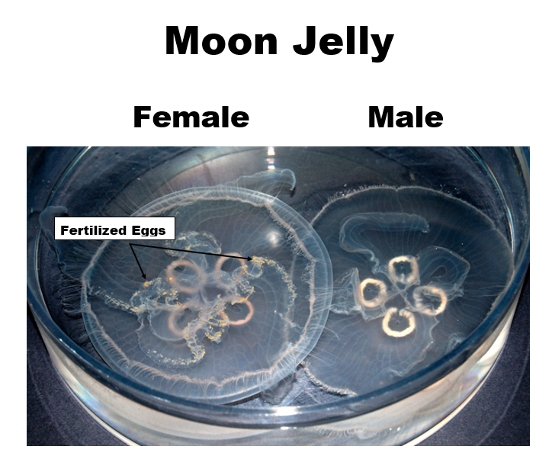
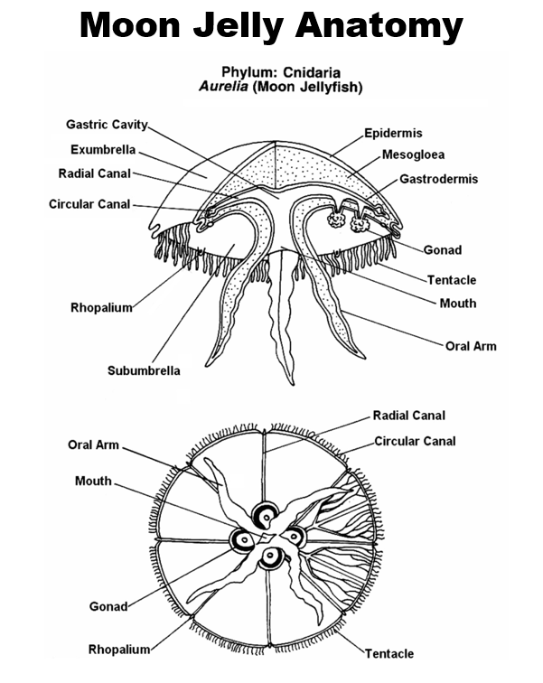

Student Jelly Station Guide

Your challenge is to make a hypothesis about how jellies can have large population blooms and what that might do to an ecosystem. Can people influence these population increases?

Think about what information you need to make a hypothesis (not a guess). Gather this information by making observations of the tanks and at the microscopes, looking at diagrams, discussing ideas with each other, and asking questions of your instructor. Below are some questions to guide you in this discovery.

- Where do moon jellies live? What habitat? How can you tell this by looking at the jellies and the design of the tanks?

- What are the parts of a jelly? Where is its mouth and stomach?

- How does it catch food?

- What do they eat? Do they eat the same thing in our tanks as they do in the wild?

- What eats them?

- Where are they in the food web?

- What is their life cycle like?

- They have both sexual and asexual reproduction. What are the advantages of this complex life cycle?

- When you look at the jelly stages under the microscope do you see any evidence of cloning?

- How do you tell male and female jellies apart?

- Are there more males or females in our tanks?

- Do you see any eggs on the females in our tanks?

What is your hypothesis?

_____________________________________________________________________________________
Ocean Institute Field Guide
Description: Silvery schooling fish
Size: To 44 cm in length (16 in.)
Color: Body is streamlined and bluish-silver in color, yellowish head, with a row of black dots along the lateral line

Habitat: Open ocean

Diet: Plankton

Predators: Brown pelican, sea lion, elephant seal, dolphin, large fish, man

Notes: Sardines are a schooling fish that feeds by opening its mouth wide and straining plankton on its gill rakers.

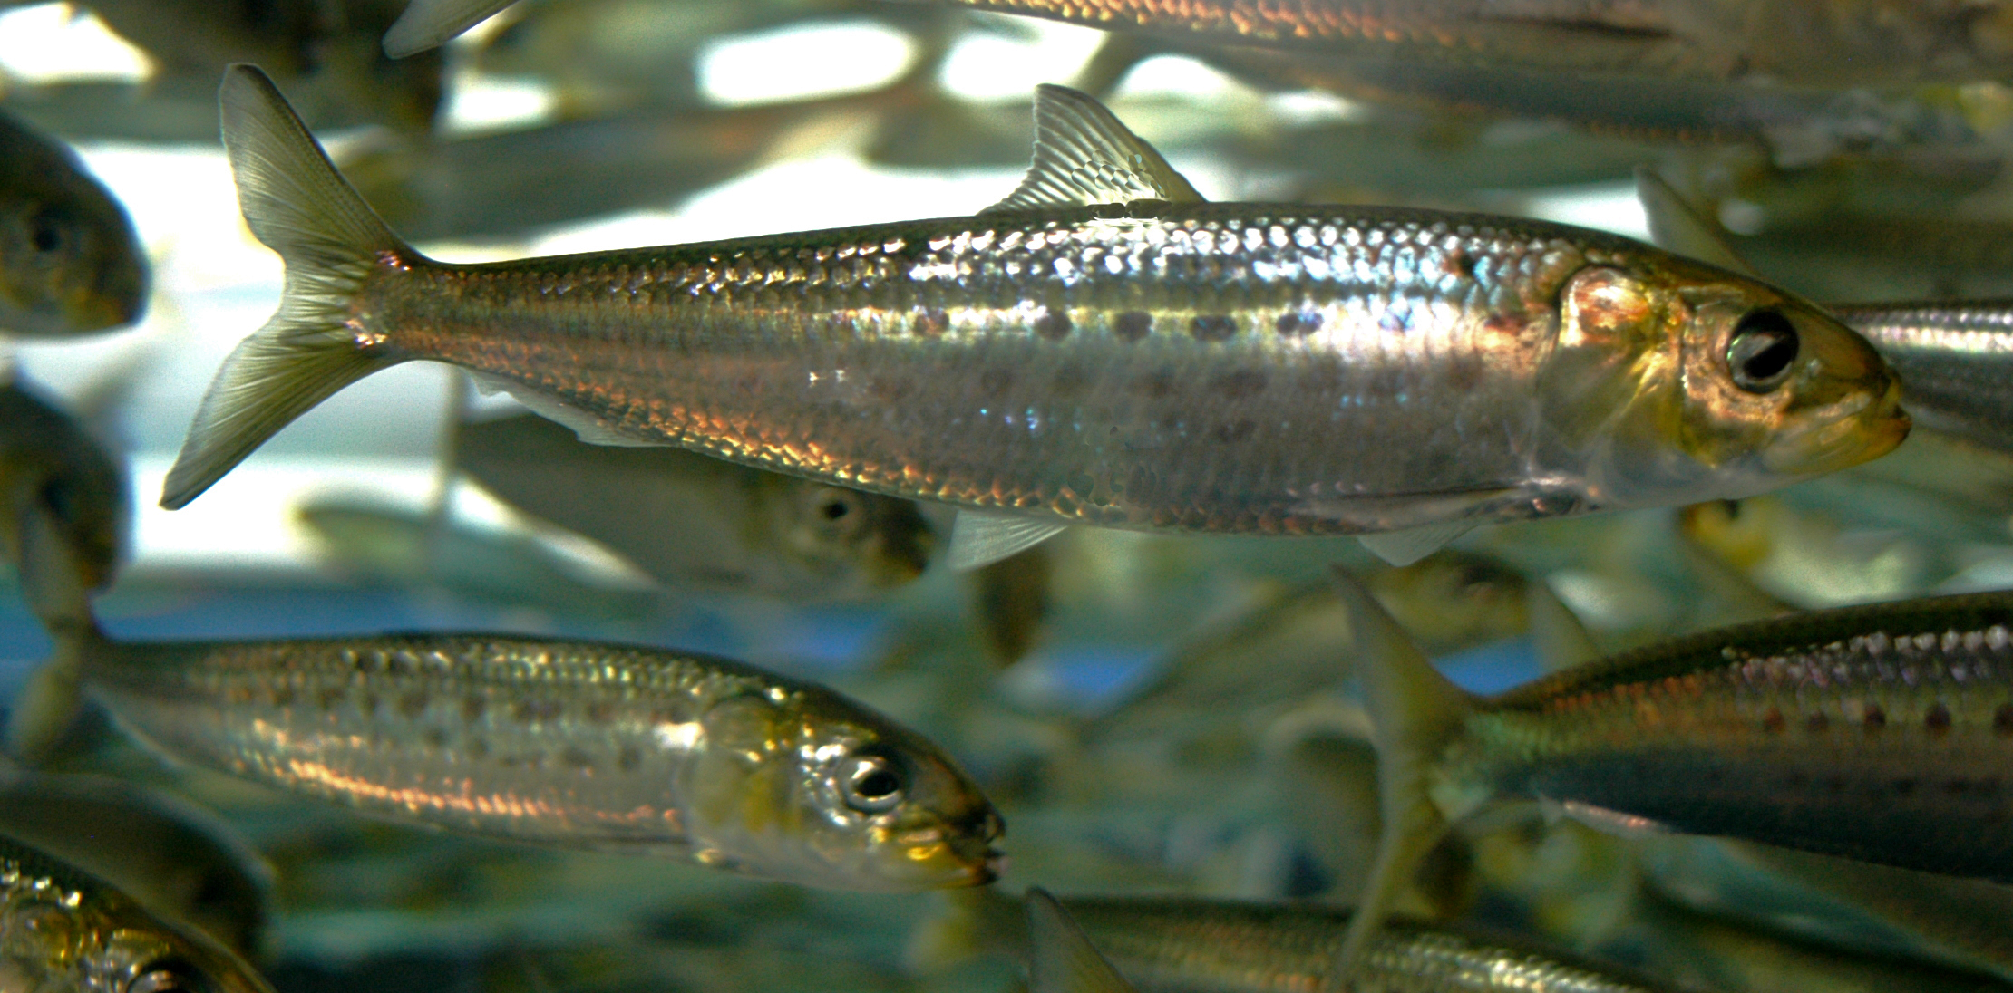

_____________________________________________________________________________________

_____________________________________________________________________________________

_____________________________________________________________________________________

BACKGROUND INFO

Ecosystems on the Endangered List
Stark new assessment warns of mass extinctions and the 'rise of slime’
Explorations e-magazine Scripps Institute of Oceanography
Jackson, director of the Scripps Center for Marine Biodiversity and Conservation, cites the effects of habitat destruction, overfishing, ocean warming, increased acidification, and massive nutrient runoff as culprits in a grand transformation of once-complex ocean ecosystems. Areas that had featured intricate marine food webs with large animals are being converted into simplistic ecosystems dominated by microbes, toxic algal blooms, jellyfish, and disease. Jackson has labeled the ongoing transformation “the rise of slime.”

Jelly Population Explosion Background Information

This is an edited version from a long article that was in the LA Times. I pulled out the information pertaining primarily to jellyfish. The whole article is worth reading, you can access it online.
http://www.latimes.com/news/local/oceans/la-me-ocean30jul30,0,952130.story

ALTERED OCEANS

A Primeval Tide of Toxins
Runoff from modern life is feeding an explosion of primitive organisms. This 'rise of slime,' as one scientist calls it, is killing larger species and sickening people.
By Kenneth R. Weiss, Times Staff Writer
July 30, 2006

In many places — the atolls of the Pacific, the shrimp beds of the Eastern Seaboard, the fiords of Norway — some of the most advanced forms of ocean life are struggling to survive while the most primitive are thriving and spreading. Fish, corals and marine mammals are dying while algae, bacteria and jellyfish are growing unchecked. Where this pattern is most pronounced, scientists evoke a scenario of evolution running in reverse, returning to the primeval seas of hundreds of millions of years ago.
Jeremy B.C. Jackson, a marine ecologist and paleontologist at the Scripps Institution of Oceanography in La Jolla, says we are witnessing "the rise of slime."
For many years, it was assumed that the oceans were too vast for humanity to damage in any lasting way. "Man marks the Earth with ruin," wrote the 19th century poet Lord Byron. "His control stops with the shore."
Even in modern times, when oil spills, chemical discharges and other industrial accidents heightened awareness of man's capacity to injure sea life, the damage was often regarded as temporary.
But over time, the accumulation of environmental pressures has altered the basic chemistry of the seas.
The causes are varied, but collectively they have made the ocean more hospitable to primitive organisms by putting too much food into the water.

Industrial society is overdosing the oceans with basic nutrients — the nitrogen, carbon, iron and phosphorous compounds that curl out of smokestacks and tailpipes, wash into the sea from fertilized lawns and cropland, seep out of septic tanks and gush from sewer pipes.
Modern industry and agriculture produce more fixed nitrogen — fertilizer, essentially — than all natural processes on land. Millions of tons of carbon dioxide and nitrogen oxide, produced by burning fossil fuels, enter the ocean every day.

These pollutants feed excessive growth of harmful algae and bacteria.
At the same time, overfishing and destruction of wetlands have diminished the competing sea life and natural buffers that once held the microbes and weeds in check.
The consequences are evident worldwide.

Organisms such as the fireweed that torments the fishermen of Moreton Bay have been around for eons. They emerged from the primordial ooze and came to dominate ancient oceans that were mostly lifeless. Over time, higher forms of life gained supremacy. Now they are under siege.

We're pushing the oceans back to the dawn of evolution," Jackson said, "a half-billion years ago when the oceans were ruled by jellyfish and bacteria."

The 55-foot commercial trawler working the Georgia coast sagged under the burden of a hefty catch. The cables pinged and groaned as if about to snap.
Working the power winch, ropes and pulleys, Grovea Simpson hoisted the net and its dripping catch over the rear deck. With a tug on the trip-rope, the bulging sack unleashed its massive load.
Plop. Splat. Whoosh. About 2,000 pounds of cannonball jellyfish slopped onto the deck. The jiggling, cantaloupe-size blobs ricocheted around the stern and slid down an opening into the boat's ice-filled hold.
The deck was streaked with purple-brown contrails of slimy residue; a stinging, ammonia-like odor filled the air.
"That's the smell of money," Simpson said, all smiles at the haul. "Jellyballs are thick today. Seven cents a pound. Yes, sir, we're making money."
Simpson would never eat a jellyfish. But shrimp have grown scarce in these waters after decades of intensive trawling. So during the winter months when jellyfish swarm, he makes his living catching what he used to consider a messy nuisance clogging his nets.
It's simple math. He can spend a week at sea scraping the ocean bottom for shrimp and be lucky to pocket $600 after paying for fuel, food, wages for crew and the boat owner's cut.

Or, in a few hours of trawling for jellyfish, he can fill up the hold, be back in port the same day and clear twice as much. The jellyfish are processed at the dock in Darien, Ga., and exported to China and Japan, where spicy jellyfish salad and soup are delicacies.
"Easy money," Simpson said. "They get so thick you can walk on them."
Jellyfish populations are growing because they can. The fish that used to compete with them for food have become scarce because of overfishing. The sea turtles that once preyed on them are nearly gone. And the plankton they love to eat are growing explosively.
As their traditional catch declines, fishermen around the world now haul in 450,000 tons of jellyfish per year, more than twice as much as a decade ago.
This is a logical step in a process that Daniel Pauly, a fisheries scientist at the University of British Columbia, calls "fishing down the food web." Fishermen first went after the largest and most popular fish, such as tuna, swordfish, cod and grouper. When those stocks were depleted, they pursued other prey, often smaller and lower on the food chain.
"We are eating bait and moving on to jellyfish and plankton," Pauly said.
In California waters, for instance, three of the top five commercial catches are not even fish. They are squid, crabs and sea urchins.
Jellyfish are flourishing in the soup, demonstrating their ability to adapt to wholesale changes — including the growing human appetite for them. Jellyfish have been around, after all, at least 500 million years, longer than most marine animals.
In the Black Sea, an Atlantic comb jelly carried in the ballast water of a ship from the East Coast of the United States took over waters saturated with farm runoff. Free of predators, the jellies gorged on plankton and fish larvae, depleting the fisheries on which the Russian and Turkish fleets depend. The plague subsided only with the accidental importation of another predatory jellyfish that ate the comb jellies.
Federal scientists tallied a tenfold increase in jellies in the Bering Sea in the 1990s. They were so thick off the Alaskan Peninsula that fishermen nicknamed it the Slime Bank. Researchers have found teeming swarms of jellyfish off Georges Bank in New England and the coast of Namibia, in the fiords of Norway and in the Gulf of Mexico. Also proliferating is the giant nomurai found off Japan, a jellyfish the size of a washing machine.

Most jellies are smaller than a fist, but their sheer numbers have gummed up fishing nets, forced the shutdown of power plants by clogging intake pipes, stranded cruise liners and disrupted operations of the world's largest aircraft carrier, the Ronald Reagan.
Of the 2,000 or so identified jellyfish species, only about 10 are commercially harvested. The largest fisheries are off China and other Asian nations. New ones are springing up in Australia, the United States, England, Namibia, Turkey and Canada as fishermen look for ways to stay in business.
Pauly, 60, predicts that future generations will see nothing odd or unappetizing about a plateful of these gelatinous blobs.
"My kids," Pauly said, "will tell their children: Eat your jellyfish."

The ancient seas contained large areas with little or no oxygen — anoxic and hypoxic zones that could never have supported sea life as we know it. It was a time when bacteria and jellyfish ruled.

Years ago, Rabalais popularized a term for this broad area off the Louisiana coast: the "dead zone." In fact, dead zones aren't really dead. They are teeming with life — most of it bacteria and other ancient creatures that evolved in an ocean without oxygen and that need little to survive.
"There are tons and tons of bacteria that live in dead zones," Rabalais said. "You see this white snot-looking stuff all over the bottom."
Other primitive life thrives too. A few worms do well, and jellyfish feast on the banquet of algae and microbes.

Robert Diaz, a professor at the Virginia Institute of Marine Science, has been tracking the spread of low-oxygen zones. He has determined that the number is nearly doubling every decade, fed by a worldwide cascade of nutrients — or as he puts it, energy. We stoke the ocean with energy streaming off the land, he said, and with no clear pathways up the food chain, this energy fuels an explosion of microbial growth.

